**APP – INSTA_CLONE**

**PROBLEM STATEMENT:**

Now-a-days people are very busy in their lives. Everyone is so busy working or studying to achieve their goals that they forget to check upon their close friends or family. Also, along with work and hustle, it is very important to take breaks, relax for some time and get some entertainment. This will refresh our mind, help us relieve stress and also allow us to work more efficiently later.

A person who works right from morning till evening will seek some relaxation once he returns home very tired. In such situations, what can he do to entertain himself without putting any physical effort?

**SOLUTION:**

With the Rapid Growth of Internet Technology in the world. Social media Plays an Important role in an individual's life. It Provides services that opened a new era for mankind in the trend of digitalization and mobility. Moreover, it provides people with various services. Insta-Clone is the most Visual Oriented and engaging Social Media Networking Site all over the World.

Insta_Clone provides users to take photos and videos, in addition, users can beautify, apply various filters, and share. It enables users to share their memories with others in the form of stories and posts. It helps them to be open to the world and gives them a stage to showcase their talent. It consists of many basic features such as capturing photos, makeover photos, sharing, and commenting. This makes it easy to learn and operate by users. And because of these features, Insta_Clone stands out from the rest of the other apps.

Besides, it establishes and maintains user-to-user relationships through user-generated content. With the help of Insta_Clone people can produce information, which helps them see more relevant things on an app that aligns with their scope of interest.

This is also used for Business purposes to target Interested Consumers through various Advertisements related to users' needs and interests. Nowadays, major social media platforms have already occupied most of the people’s leisure time and become an indispensable part of people’s daily life.

**Screenshots of App:**

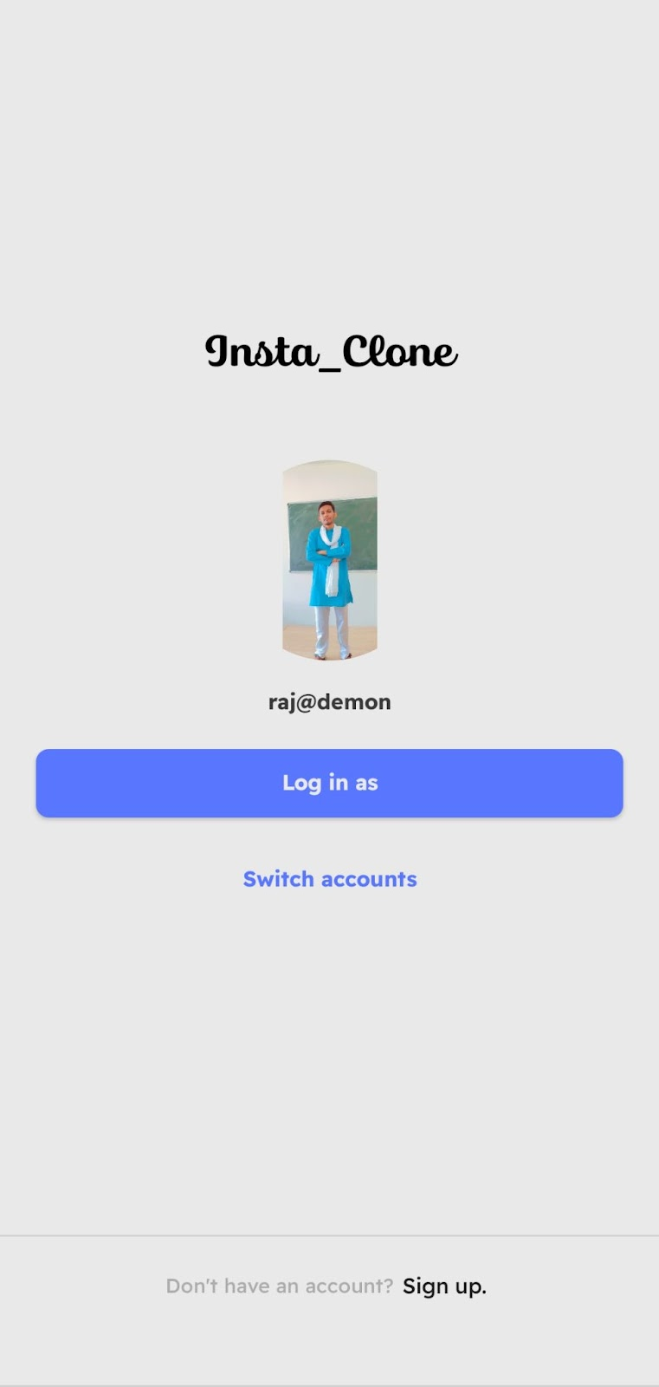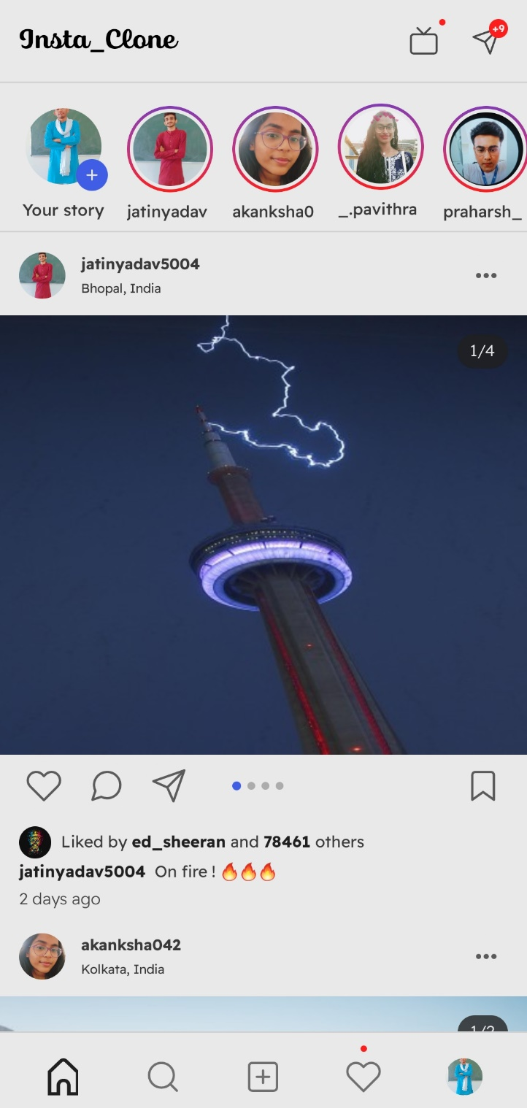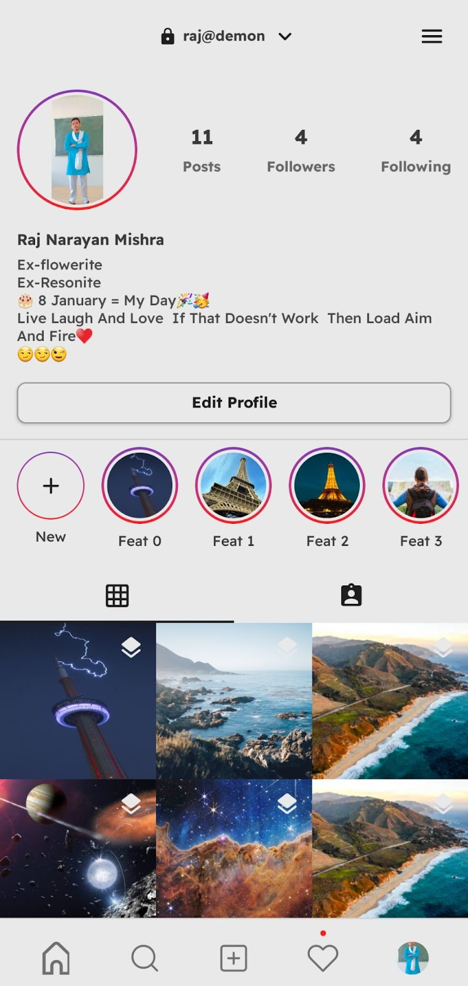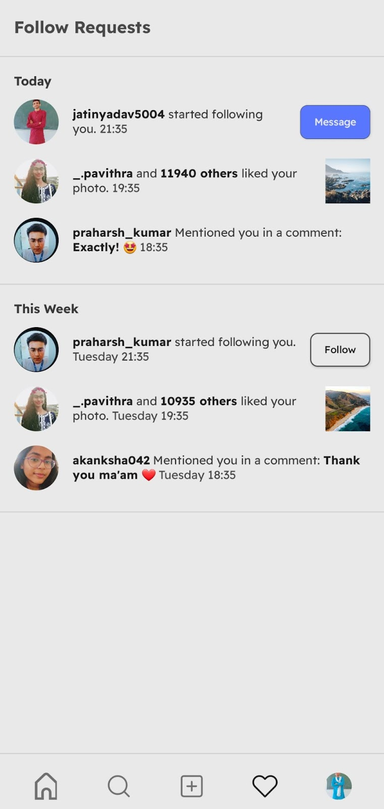

**Functionality & Concepts used:**

1. Jetpack Compose for UI
2. Compose animations
3. Compose Navigation
4. State management
5. CompositonLocalProvider
6. MVVM architecture
7. Lottie animations
8. Launched Effect
9. Coroutines
10. Timber for logging
11. Accompanist Placeholder to show loading effect "Shimmer"

**Application Link & Future Scope:**

**Application link:** <https://drive.google.com/file/d/1maQPjUKnl7vmtvW1vleq17cLaOGETkh2/view?usp=sharing>

**Future Scope:**

The app can be implemented for the larger population of the world for getting them publicly and socially connected to each other, beyond the geographical needs.